Effect of Geographical Diversification on Informational Efficiency in Emerging Countries

First-Name Last-Name¹, Catherine Soke-Fun Ho²∗, Ruhani Hj. Ali ³ &
Jeng-Hoong Woon⁴
¹Faculty, University, Country OR Company, State, Country.
²Faculty of Business Management, Universiti Teknologi MARA, Malaysia.
³Graduate School of Business, Universiti Sains Malaysia, Malaysia.
⁴Intel Technology Sdn Bhd, Penang, Malaysia.

Abstract: Research Question: In one sentence, define the key features of the research question or problem statement. Motivation: In a few sentences, capture the core scholarly motivation for the study. If relevant, identify a ‘puzzle’ that this research aims to resolve. Identify up to 3 key papers upon which the research builds. What’s new? Highlight where novelty exists in the study; how does it improve or build on existing literature? So what? Outline the primary reason why it is important to know the answer to your research question. Idea: Articulate the core idea behind the research – what specifically does the study do? If relevant: articulate the central hypothesis; highlight key independent variables and dependent variable(s). Data: Provide an overview of what data were collected/analysed/used in the study; including data source(s), time period, sample size and measurement tool(s). Method/Tools: Provide a brief summary of the empirical framework, research design and approach. Findings: Highlight the key takeaway points. Highlight any novel result – how do the findings agree/disagree with existing literature? What do the findings add? Highlight any important implications this research has for influence in real-world decisions/behaviour/activity. Contributions: Outline the primary contribution of this paper to the relevant research literature. [The abstract with 300-350 words in length.]

Keywords: First keyword, second keyword, third keyword (minimum), fourth keyword, fifth keyword, sixth keyword (maximum).
JEL classification: X10, X12, X14

- Introduction (bold, 10pt)
This is the live-template that offers authors the formatting specifications in preparing manuscripts for the Capital Markets Review. In your submission(s), do keep the page margins, column width of this manuscript template. The manuscript may be written in English or Bahasa Malaysia using MS Word, Times New Roman and 1.0 spacing. Please note that there is no indentation in the first paragraph of every section.
Indentation (0.5cm) starts from second paragraph. Please use APA style in citation. Some examples of citations which placed at the end of a sentence are shown as follow (Kek and Goh, 2015; Kwiatkowski et al., 1992; Li, 2010a, 2010b). Use et al. if there are more than two authors. For example, Bahmani-Oskooee et al. (2000) also stated that …

2. New Section (bold, 10pt)
This section shows the numbering of each section. There is no restrictions on number of pages so it is depends on the authors to decide on how many chapters/sections they wish to include in their manuscript.
Indentation starts from second paragraph….

2.1 Subsection (bold, 10pt)
2.1.1 Subsequent Subsection (Italic, 10pt)
In the case that you have four levels of headings, please use the numbering format 2.1.1(a) instead of 2.1.1.1. Then, the numbering is followed by 2.1.1(b) instead of 2.1.1.2.

2.1.1(a) Sub-Subsequent Subsection (Italic, 10pt)

2.1.1(b) Sub-Subsequent Subsection (Italic, 10pt)

2.1.2 Subsequent Subsection (Italic, 10pt)
This section shows how to number your equations, tables and figures. Equations should be numbered consecutively throughout the manuscript as (1), (2), etc. against the right-hand margin of the page. You can use the no border table (as shown below) to assist you in numbering the equation, so that the equation is align left while equation number is align right. Please be sure to carefully check your equations before submission.

 | Performance_{it} = α + β₁DGLC_{it} + β₂SIZE_{it} + β₃LEV_{it} + β₄LIQ_{it} +β₅BS_{it} + ε_{it} | (1)

Tables and figures should be embedded in the text. All tables and figures should be numbered consecutively with Arabic numerals, have a brief title, and be referred to in the text. For the table title, please capitalize the first letter of the first word only, except special names such as Bursa Malaysia. The entire table should be presented in one page unless too long, landscape table is acceptable. Vertical lines should not be used in table. Explanatory notes should be placed at the bottom of the table. The word ‘Notes’ precedes the table notes and has to be set in italics. Tables and their respective titles should be aligned to the left.

Table 1: Descriptive statistics - mean values of variables use in the study (9pt, left aligned)
Please use suitable font for table content, maximum 9pt | GLCs | Non-GLCs | t-statistic of the difference
Return on assets | 0.0339 | 0.0810 | -4.7319***
Return on equity | 0.0520 | 0.2468 | -2.5624**
Tobin’s Q | 0.8530 | 2.0497 | -6.9949***
Independent directors | 0.4509 | 0.3594 | 4.4035***
Non-duality | 0.8571 | 0.8442 | 0.2757
Notes: The numbers of companies use in the study are 13 GLCs and 13 non-GLCs over a six-year period. ***and ** indicate significance at the 1% and 5% levels, respectively (two-tailed). The official exchange rate as at 30 December 2013 is RM1.00 = USD0.30. (8 pt)

All figures should be provided as high-quality black and white printouts, suitable for reproduction. Figures and their respective titles should be aligned to the centre.

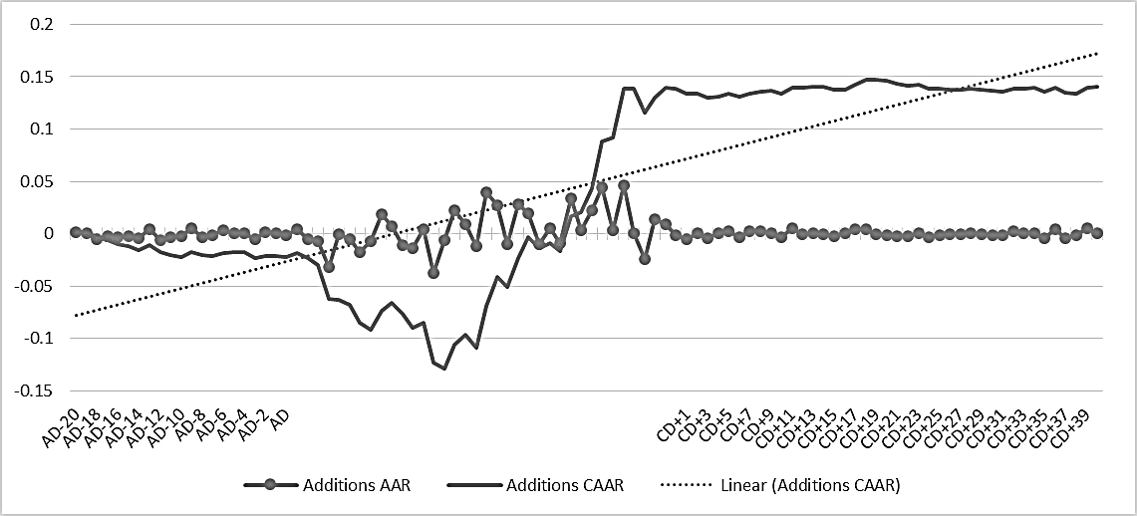
Figure 1: The AAR and CAAR for stocks added in Index, Panel A (9pt, centered)

References (Bold, 10pt; For below content: 9pt, justify, arrange according to the alphabetical order, strictly adhere to below references style)
Kek, J. Y.-E., & Goh, K.-L. (2015). Informational content of yield spread: Predicting economic growth of Malaysia. Capital Markets Review, 23(1), 84-95.
Kwiatkowski, D., Phillips, P. C. B., Schmidt, P., & Shin, Y. (1992). Testing the null hypothesis of stationarity against the alternative of a unit root: How sure are we that economic time series have a unit root? Journal of Econometrics, 54(1), 159-178.
Li, F. (2010a). The information content of forward-looking statements in corporate filings - A naïve Bayesian machine learning approach. Journal of Accounting Research, 48(5), 1049-1102.
Li, F. (2010b). Textual analysis of corporate disclosures: A survey of the literature. Journal of Accounting Literature, 29, 143-165.

**SOME EXAMPLES IN REFERENCES**
1. Special family names
Bahmani-Oskooee, M., Chang, T., Yang, M.-S., & Yang, H.-L. (2016). Revisiting real interest rate parity in BRICS countries using ADL test for threshold cointegration. Economic Analysis and Policy, 51, 86-89.
De Los Rios, A. D., & Sentana, E. (2011). Testing uncovered interest parity: A continuous-time approach. International Economic Review, 52(4), 1215-1251.
De Truchis, G., Dell’Eva, C., & Keddad, B. (2017). On exchange rate comovements: New evidence from a Taylor rule fundamentals model with adaptive learning. Journal of International Financial Markets, Institution and Money, 48, 82-98.

2. Working paper
Blouin, J., Raedy, J. S., & Shackelford, D. A. (2000). The impact of capital gains taxes on stock price reactions to S&P 500 inclusion (NBER Working Paper No. 8011). Retrieved from National Bureau of Economic Research website: http://www.nber.org/papers/w8011
Kandil, M. E., & Bahmani-Oskooee, M. (2007). Exchange rate fluctuations and output in oil-producing countries: The case of Iran (IMF Working Paper No. WP/07/113). Retrieved from International Monetary Fund website: https://www.imf.org/~/media/Websites/IMF/imported-full-text-pdf/external/pubs/ft/wp/2007/_wp07113.ashx

3. Unpublished working paper
Brau, J. C., & McQueen, G. (2000). IPO lockups: A signaling solution to an adverse selection problem. Unpublished Working Paper, Brigham Young University.
Brav, A., & Gompers, P. A. (2000). Insider trading subsequent to initial public offerings: Evidence from expirations of lock-up provisions. Unpublished Working Paper, Duke University.

4. Book
Enders, W. (2010). Applied econometric time series (3rd ed.). New Jersey, NY: John Wiley & Sons.
Ohmae, K. (1996). The end of nation state: The rise of regional economies. New York, NY: Free Press Paperbacks.

5. Chapter in Book
Ibbotson, R. G., & Ritter, J. R. (1995). Initial public offerings. In R. A. Jarrow, V. Maksimovic & W. T. Ziemba (Eds.), Handbooks in operations research and management science (Vol. 9, pp. 993–1016). Amsterdam, The Netherlands: Elsevier.
Newberry, D. M. (1992). Futures markets: Hedging and speculation. In P. Newman, M. Milgate & J. Eatwell (Eds.), The new Palgrave dictionary of money and finance (Vol. 2, pp. 207-210). London, UK: Macmillan.
Schwarz, N. (2002). Situated cognition and the wisdom of feelings: Cognitive tuning. In L. F. Barrett & P. Salovey (Eds.), The wisdom in feeling (pp. 144-166). New York, NY: Guilford Press.

6. Online Report from official organization website
Malaysian Palm Oil Board. (2015). Annual Report 2015. Retrieved from http://bepi.mpob.gov.my/images/overview/Overview_of_Industry_2015.pdf
Unites States Department of Agriculture Foreign Agricultural Service. (2014). Malaysia Biofuels Annual 2014 (GAIN Report Number: MY4011). Retrieved from https://gain.fas.usda.gov/Recent%20GAIN%20Publications/Biofuels%20Annual_Kuala%20Lumpur_Malaysia_6-25-2014.pdf

7. Information from official website
Ministry of Agricultural and Agro-Based Malaysia. (2014). National Agro-Food Policy. Retrieved from http://www.kada.gov.my/en/web/guest/dasar-agro-makanan-negara

∗ Corresponding author: Catherine Soke-Fun Ho. Tel.: 604-1234567. Fax: 604-1234568. Email: abcdef123@abc.com Acknowledgements: Please delete this Acknowledgements section if there is no acknowledgements. Received XX Aug 2019; Final revised XX Oct 2019; Accepted XX Nov 2019; Available online XX Dec 2019. To link to this article: XXXX © Malaysian Finance Association, 20XX. This work is licensed under the terms of the Creative Commons Attribution (CC BY) (http://creativecommons.org/licenses/by/4.0/).

